

**Tobor**

Email automation

Detailed Process Description

Version 0.1

Revision History

|  |  |  |  |
| --- | --- | --- | --- |
| **Date Issued** | **Version** | **Description** | **Author** |
| 12/06/2020 | 0.1 | Draft | Premal Nayee |
| *Date* | *Version Number* | *Draft / Final etc.* | *Name* |
| *Date* | *Version Number* | *Draft / Final etc.* | *Name* |

Contributors

The content of this document has been authored with the combined input of the following group of key individuals.

|  |  |  |
| --- | --- | --- |
| **Name** | **Role** | **Area** |
| Roberto Fernandez | Application Manager and Project PM | Backend / Tobor Inc |
| *Name* | *Job Title* | *Dept / Company* |
| *Name* | *Job Title* | *Dept / Company* |

Business Sign-off

The following table contains the people required to sign-off and/or review this document and those that require the document for information only.

|  |  |  |
| --- | --- | --- |
| **Name** | **Department** | **Responsibility** |
| *Name* | *Department* | *Information / Sign off / Review* |
| *Name* | *Department* | *Information / Sign off / Review* |
| *Name* | *Department* | *Information / Sign off / Review* |

Document Classification

|  |  |
| --- | --- |
| **Classification** | *e.g. Company Confidential* |
| Definition | *e.g. Information is company confidential and needs to be protected* |
| Context | *e.g. Where loss of information confidentiality would result in significant harm to the interests of the Organisation, financial loss, embarrassment or loss of information* |
|  |  |

Contents

1 Introduction 4

2 Manual Process 4

2.1 Overview 4

2.2 Detailed Process Flow 4

3 Automation Proposal 4

3.1 Overview 4

3.2 Automated Process Flow 4

3.3 Target Systems & User Requirements 4

3.4 Impacted Business Areas 5

3.5 Workload 5

3.6 Operational Constraints 5

3.7 Delivery 5

3.8 Contact List 5

4 Automation Details 6

4.1 Automation Walkthrough 6

4.1.1 *First robot action* 6

4.1.2 *second robot action* 6

4.1.3 *third robot action etc.* 6

4.2 Reporting 6

4.2.1 Business Exceptions 6

4.2.2 System Exceptions 6

4.2.3 Performance 7

4.2.4 Triggers 8

# 1 Introduction

*Background to the situation and an overview of the opportunity for automation.*

Tobor Inc has recently released a new app which has generated more users than expected. The process of adding new users is labour some so much so that the backend application manager is spending approximately 50% of his day. The process of adding new users requires obtaining information from emails and manually entering the user’s details into the internal systems. After which the users periodically receive content.

# 2 Manual Process

## 2.1 Overview

*Overview of the manual process as it stands currently. Includes bullet pointed list of high-level steps to take to run the process.:*

* *Step 1*
* *Step 2*
* *Step 3*
* *etc.*

*Acronyms – detail the meanings of any acronyms used above e.g. systems, clients etc.*

* Step 1: Look through inbox and sort emails by the action to be carried out
* Step 2a: With the emails that are asking to add user, then extract fields from emails and add user to the content delivery system
* Step 2b: With the emails that are asking to remove or update user details, then extract the relevant fields and make the necessary changes to the internal system

## 2.2 Detailed Process Flow

*Detailed flow diagram covering* ***all*** *steps in the current manual process*

*?*

# 3 Automation Proposal

## 3.1 Overview

*High level overview of the proposed automation, including detail around the type of automation*

The process will be automated using UiPath. It will include integration with MS outlook and will be scheduled to run every hour of every day.

## 3.2 Automated Process Flow

*If the automation process flow adheres to the manual process flow above, there is little need to duplicate. A statement to that effect should suffice, confirming all actions will be automated. Otherwise, a detailed flow should be presented.*

Manual process will be automated.

## 3.3 Target Systems & User Requirements

| Name | Description | User Permissions/Access |
| --- | --- | --- |
| MS Outlook | Email Inbox | Robot will require read/write access to the receptionist’s mailbox to send and receive emails to everyone in the office |
|  |  |  |
| Receptionist computer |  | Will need access to install robot on receptionist |

## 3.4 Impacted Business Areas

* *Department / Areas affected by the automation*
* All employees will be affected, but may not realise the difference
* The receptionist will notice the difference

## 3.5 Workload

*Metrics related to the automation, table example below*

|  |  |
| --- | --- |
| *Max. no. of Login Requests per week* | *70* |
| *Min. no. of Login Requests per week* | *10* |
| *Average no. of Login Requests per week* | *50* |
| *Are there any periods when a higher workload is anticipated?* | *None* |
| *How many people do this process per week?* | *1* |

***Summary of average time process takes a user to run manually, include timings of any dependant parts such as responses coming back from 3rd parties.***

***Automating the steps below will realise an average time saving of 2 hours per week for <Process Name>:***

* *List of manual steps with manual execution time (Breakdown of all time saved)*

*Acronyms – detail the meanings of any acronyms used above e.g. systems, clients etc.*

## 3.6 Operational Constraints

* *List of all operational constraints. Examples could be working hours, system availability etc. – essentially anything that could have a bearing on how the automation can function.*

## 3.7 Delivery

*The time scale for the development, testing and delivery of this project. In the early stages this may indicate the timescale is to be finalised.*

## 3.8 Contact List

*List of key contacts for the project, both QA Ltd and Client e.g.*

*RPA Programme Sponsor – Gillian Lomax*

*Head of Operations – Harry Grainger*

*RPA Project Manager – Carrie Smith*

*RPA Consultant – Premal*

*Receptionist – Naomi Watts*

# 4 Automation Details

## 4.1 Automation Walkthrough

### 4.1.1 *First robot action*

* *Description of first Robot step to complete action, include screenshots where necessary*
* *Description of second Robot step to complete action, include screenshots where necessary*
* *Etc.*

### 4.1.2 *second robot action*

* *Description of first Robot step to complete action, include screenshots where necessary*
* *Description of second Robot step to complete action, include screenshots where necessary*
* *Etc.*

### 4.1.3 *third robot action etc.*

* *Continue as required to complete all Robot actions within the automation*

## 4.2 Reporting

### 4.2.1 Business Exceptions

|  |  |
| --- | --- |
| Exception | Solution |
| *List of expected or assumed exceptions* | *Details of method of handling exception* |
|  |  |
|  |  |
|  |  |
|  |  |
|  |  |

### 4.2.2 System Exceptions

|  |  |
| --- | --- |
| Exception | Solution |
| *List of expected or assumed exceptions* | *Details of method of handling exception* |

A performance report will be emailed to *<Client Contact>* each time the process runs (showing worked cases, exceptions and a cumulative processing log)

### 4.2.3 Performance

Once the processes have successfully completed a performance report and processing log will be emailed to *<Client Contact>* as an excel file.

**Performance Report**

This will contain all exceptions (business and system) and successes for the automated Process, based on the last automation execution completion (i.e. based on the last time the process ran)

EXAMPLE REPORT

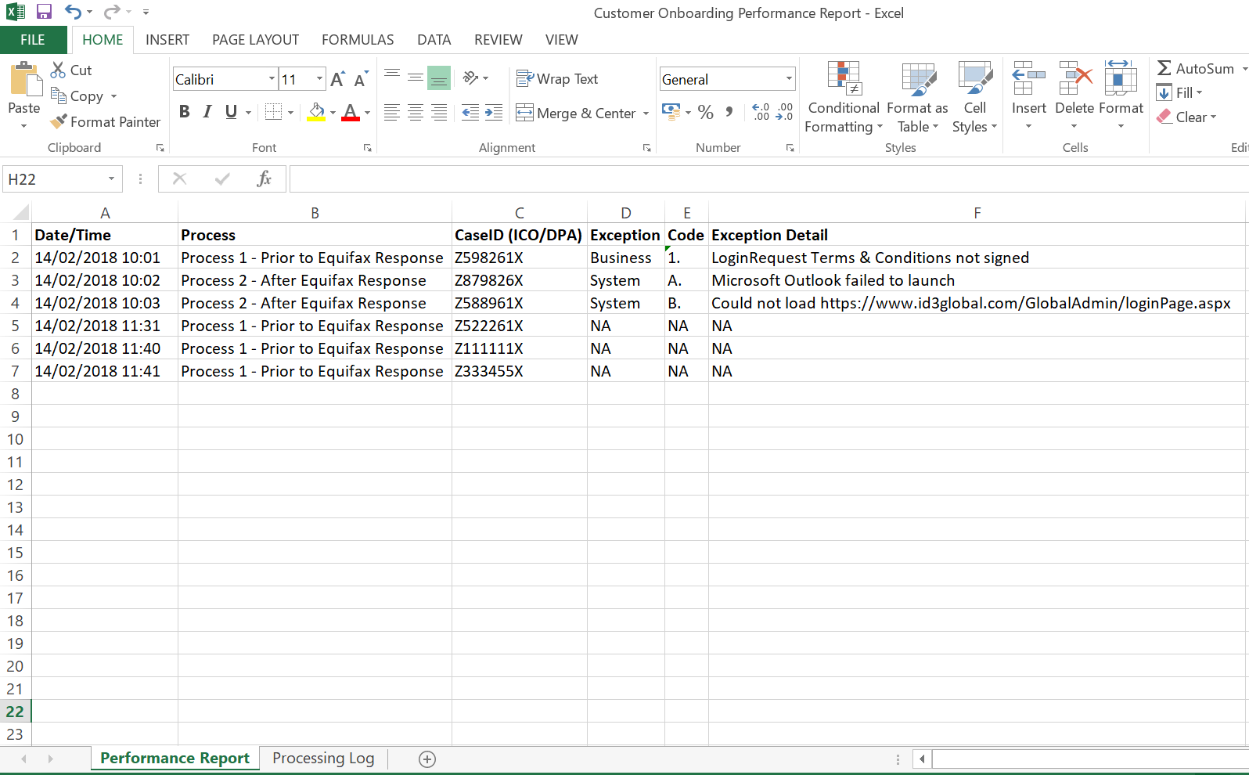

CredBest

CredBest

CredBest

CredBest

CredBest

CredBest

www.xip.com/Admin/loginPage.aspx

**Processing Log**

This will show cumulative successes from the automated Process:

EXAMPLE REPORT

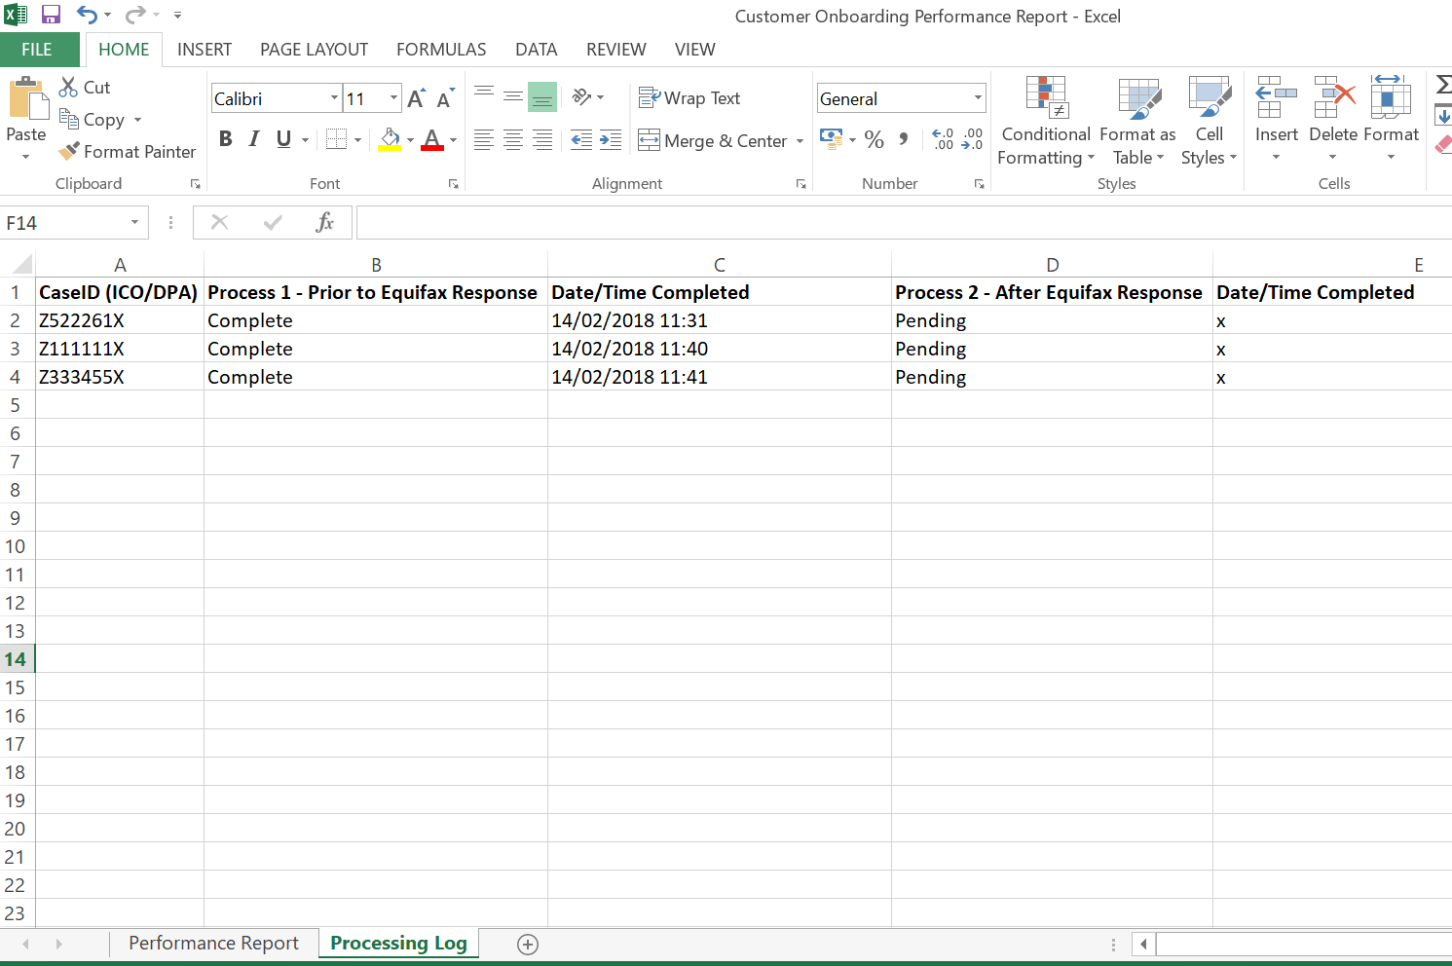

**CredBest**

**CredBest**

### 4.2.4 Triggers

*Definition of how the Robot will be triggered. This could simply define that this is a manual trigger i.e. an attended start, or could indicate more advanced triggers such as on a particular event or schedule.*

**UPDATE THE TABLE OF CONTENTS AND ENSURE ALL RED TEXT HAS BEEN UPDATED/REMOVED PRIOR TO DISTRIBUTION**